Day 378 — Hashing + Heap + Advanced DSA

Learning roadmap
01
Hashing fundamentals
Hash functions, collisions, load factor and complexity
02
Collision handling
Separate chaining, linear probing and quadratic probing
03
STL hash containers
unordered_map, unordered_set and frequency patterns
04
Binary heap
Array representation, sift-up, sift-down and heap construction
05
Priority queue
Max-heap, min-heap, custom priorities and comparators
06
Advanced DSA problems
Top K, Kth largest, streaming median, merge K lists and scheduling
07
Revision and practice
Complexity tables, common mistakes, interview questions and quiz

Part 1 — Hashing
1. What is hashing?
Hashing is a method of mapping a key to an index in a hash table using a hash function.
\[ h(key)=key\bmod tableSize \]
For a table of size 10:
Key | Hash calculation | Index
21 | \(21\bmod10\) | 1
31 | \(31\bmod10\) | 1
42 | \(42\bmod10\) | 2
55 | \(55\bmod10\) | 5
Keys 21 and 31 collide because they map to the same index.
Essential terminology
- Key: the value used to identify a record.
- Hash function: calculates a hash value from the key.
- Hash table: stores entries at calculated positions.
- Collision: two distinct keys map to the same bucket or slot.
- Bucket: a position in a hash table.
- Load factor: number of stored elements divided by the number of buckets.
- Rehashing: rebuilding the table, usually with a new capacity, and redistributing its entries.
2. Collision handling techniques
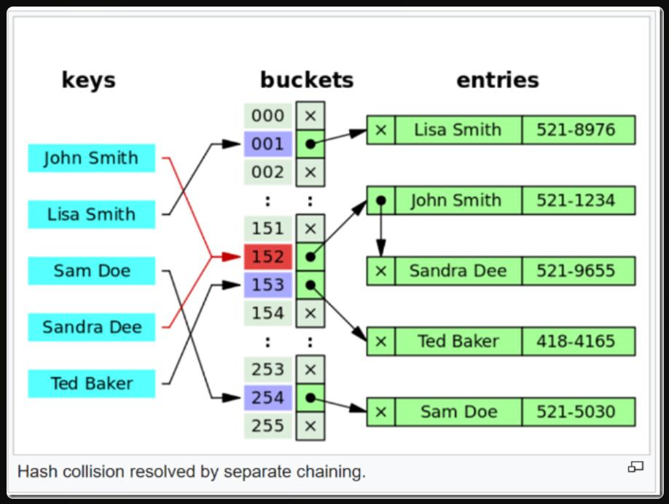 Separate chaining
Each bucket holds a collection of entries. Multiple keys can share a bucket.
Average search can be \(O(1)\) with good distribution; worst case is \(O(n)\).

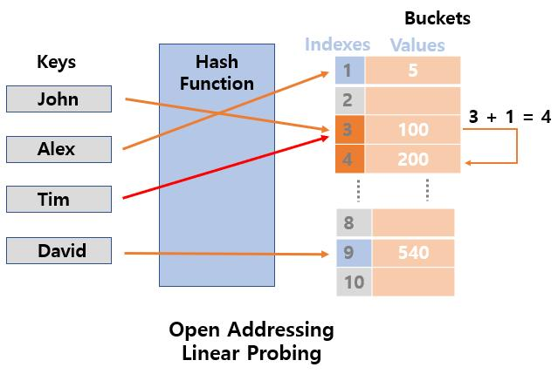 Linear probing
If the calculated slot is occupied, check the next slot, wrapping around the table.
h_i(k)=(h(k)+i) mod m

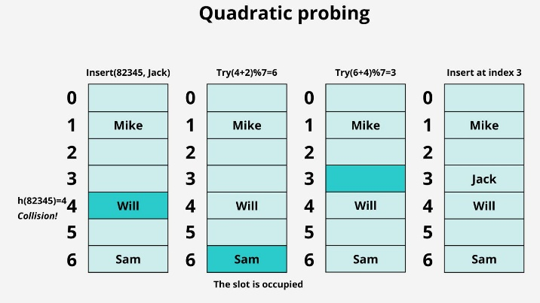 Quadratic probing
Check slots using quadratic offsets.
h_i(k)=(h(k)+i^2) mod m
The chosen table size and probe sequence matter; not every slot is guaranteed to be visited for every configuration.

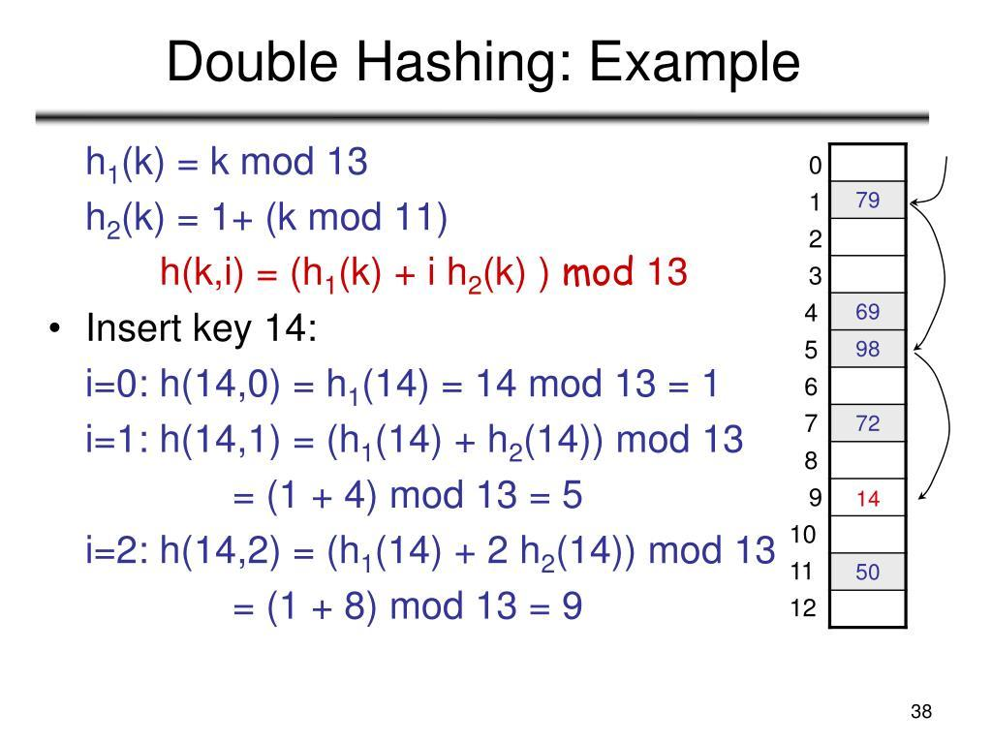 Double hashing
A second hash function determines the step size.
h_i(k)=(h_1(k)+i h_2(k)) mod m
The step size should be compatible with the table size so the probe sequence can cover the table.

3. Load factor and rehashing
alpha= {n}/{m}
Here, \(n\) is the number of entries and \(m\) is the number of buckets.
For 8 entries and 10 buckets, the load factor is \(0.8\).
As the load factor increases, collisions generally become more frequent. Many hash table implementations grow their bucket array when a configured threshold is exceeded.

4. Complete program — custom hash table using separate chaining
This implementation uses a vector of linked lists and supports insertion, search, deletion, display and collision counting.

#include <iostream>
#include <vector>
#include <list>
#include <utility>
using namespace std;

class HashTable { private:
vector<list<pair<int, string>>> table;
int capacity;
int entries;

int hashFunction(int key) const {
int index = key % capacity;
return index < 0 ? index + capacity : index;
}

public:
explicit HashTable(int size = 10)
: capacity(size > 0 ? size : 10),
entries(0),
table(capacity) {}

void insert(int key, const string& value) {
int index = hashFunction(key);

for (auto& entry : table[index]) {
if (entry.first == key) {
entry.second = value;
cout << "Updated key " << key << '\n';
return;
}
}

table[index].push_back({key, value});
++entries;
cout << "Inserted key " << key << '\n';
}

bool search(int key) const {
int index = hashFunction(key);

for (const auto& entry : table[index]) {
if (entry.first == key) {
cout << "Found: " << entry.second << '\n';
return true;
}
}

cout << "Key not found\n";
return false;
}

bool remove(int key) {
int index = hashFunction(key);

for (auto it = table[index].begin();
it != table[index].end(); ++it) {
if (it->first == key) {
table[index].erase(it);
--entries;
cout << "Deleted key " << key << '\n';
return true;
}
}

cout << "Key not found\n";
return false;
}

void display() const {

for (int i = 0; i < capacity; ++i) {
cout << i << ": ";

for (const auto& entry : table[i]) {
cout << '(' << entry.first << ", "
<< entry.second << ") -> ";
}

cout << "NULL\n";
}
}

double loadFactor() const {
return static_cast<double>(entries) / capacity;
}
};

int main() {
HashTable ht(10);

ht.insert(21, "Harshit");
ht.insert(31, "Aman");
ht.insert(42, "Rahul");

cout << "\nHash table:\n";
ht.display();

cout << "\nSearching:\n";
ht.search(31);
ht.search(99);

cout << "\nDeleting:\n";
ht.remove(21);

cout << "\nAfter deletion:\n";
ht.display();

cout << "\nLoad factor: " << ht.loadFactor() << '\n';
return 0;
}
Why this demonstrates chaining: keys 21 and 31 both map to bucket 1, but both entries can coexist in that bucket.
Complexity for \(n\) entries and \(m\) buckets:
- Expected search, insertion and deletion: approximately \(O(1+\alpha)\), assuming reasonable distribution.
- Worst case per operation: \(O(n)\).
- Space: \(O(n+m)\).
This teaching implementation does not resize itself; a production hash table would normally include resizing and rehashing.

5. Complete program — open addressing with linear probing
This version demonstrates how to insert, search and delete keys without linked lists. A special state marks deleted slots so a search can continue through them.

#include <iostream>
#include <vector>
using namespace std;

class LinearProbingHash {
private:
enum State { EMPTY, OCCUPIED, DELETED };

struct Slot {
int key = 0;
State state = EMPTY;
};

vector<Slot> table;
int capacity;
int count = 0;

int hashFunction(int key) const {
int index = key % capacity;
return index < 0 ? index + capacity : index;
}

public:
explicit LinearProbingHash(int size)
: table(size > 0 ? size : 10),
capacity(size > 0 ? size : 10) {}

bool insert(int key) {
if (count == capacity) {
cout << "Table is full\n";
return false;
}

int start = hashFunction(key);
int firstDeleted = -1;

for (int i = 0; i < capacity; ++i) {
int index = (start + i) % capacity;
Slot& slot = table[index];

if (slot.state == OCCUPIED && slot.key == key) {
cout << "Duplicate key\n";
return false;
}

if (slot.state == DELETED && firstDeleted == -1) {
firstDeleted = index;
}

if (slot.state == EMPTY) {
int target = firstDeleted == -1
? index : firstDeleted;

table[target].key = key;
table[target].state = OCCUPIED;
++count;
return true;
}
}

if (firstDeleted != -1) {
table[firstDeleted].key = key;
table[firstDeleted].state = OCCUPIED;
++count;
return true;
}

return false;
}

bool search(int key) const {
int start = hashFunction(key);

for (int i = 0; i < capacity; ++i) {
int index = (start + i) % capacity;
const Slot& slot = table[index];

if (slot.state == EMPTY) {
return false;
}

if (slot.state == OCCUPIED && slot.key == key) {
return true;
}
}

return false;
}

bool remove(int key) {
int start = hashFunction(key);

for (int i = 0; i < capacity; ++i) {
int index = (start + i) % capacity;
Slot& slot = table[index];

if (slot.state == EMPTY) {
return false;
}

if (slot.state == OCCUPIED && slot.key == key) {
slot.state = DELETED;
--count;
return true;
}
}

return false;
}

void display() const {
for (int i = 0; i < capacity; ++i) {
cout << i << ": ";

if (table[i].state == EMPTY) {
cout << "EMPTY";
} else if (table[i].state == DELETED) {
cout << "DELETED";
} else {
cout << table[i].key;
}

cout << '\n';
}
}
};

int main() {
LinearProbingHash ht(7);

ht.insert(10);
ht.insert(17);
ht.insert(24);
ht.insert(5);

cout << "After insertion:\n";
ht.display();

cout << "\nSearch 24: " << ht.search(24) << '\n';

ht.remove(17);

cout << "\nAfter deleting 17:\n";
ht.display();

cout << "\nSearch 24 after deletion: "
<< ht.search(24) << '\n';

ht.insert(31);

cout << "\nAfter inserting 31:\n";
ht.display();

return 0;
}
Important: deletion uses a tombstone (DELETED), not EMPTY. If the deleted slot were marked empty, a later search might incorrectly stop before reaching a key that was displaced by a collision.

6. STL hashing — unordered_map and unordered_set
In normal problem-solving, C++ STL containers are generally preferable to writing a custom hash table.
Program A — frequency counter
Counts how many times each number occurs.

#include <iostream>
#include <unordered_map>
#include <vector>
using namespace std;

int main() {
vector<int> numbers = {4, 2, 4, 3, 2, 4, 5, 3};
unordered_map<int, int> frequency;

for (int number : numbers) {
++frequency[number];
}

for (const auto& entry : frequency) {
cout << entry.first << " occurs "
<< entry.second << " times\n";
}

return 0;
}
The output order is unspecified because unordered_map does not sort its keys.
- Expected time: \(O(n)\).
- Extra space: \(O(u)\), where \(u\) is the number of unique values.
Program B — duplicate detection

#include <iostream>
#include <unordered_set>
#include <vector>
using namespace std;

int main() {
vector<int> numbers = {10, 20, 30, 20, 40, 10};
unordered_set<int> seen;

for (int number : numbers) {
if (seen.find(number) != seen.end()) {
cout << "Duplicate found: " << number << '\n';
} else {
seen.insert(number);
}
}

return 0;
}
Expected time: \(O(n)\). Each repeated occurrence is reported.
Program C — Two Sum using hashing
Given an array and a target, find two indices whose values sum to the target.

#include <iostream>
#include <unordered_map>
#include <vector>
using namespace std;

bool twoSum(const vector<int>& nums, int target) {
unordered_map<int, int> indexOf;

for (int i = 0; i < static_cast<int>(nums.size()); ++i) {
int complement = target - nums[i];

auto it = indexOf.find(complement);
if (it != indexOf.end()) {
cout << "Indices: " << it->second
<< " and " << i << '\n';
return true;
}

indexOf.emplace(nums[i], i);
}

cout << "No pair found\n";
return false;
}

int main() {
vector<int> nums = {2, 7, 11, 15};
int target = 9;

twoSum(nums, target);

return 0;
}
Why it works: for each number \(x\), the algorithm checks whether \(target-x\) has already been seen. This avoids checking every possible pair.
- Brute-force time: \(O(n^2)\).
- Hashing time: expected \(O(n)\).
- Extra space: \(O(n)\).
Part 2 — Binary heap
7. Heap properties
A binary heap combines two properties:
- Shape property: it is a complete binary tree.
- Order property: each parent obeys the heap's ordering rule.
In a max-heap, a parent is at least as large as its children. In a min-heap, a parent is at most as large as its children.
A heap is not a binary search tree. There is no guarantee that every value in the left subtree is smaller than every value in the right subtree.
Array index relationships
For a zero-indexed array:
Relationship | Formula
Parent | (i - 1) / 2
Left child | 2 * i + 1
Right child | 2 * i + 2
The parent formula is only used when i > 0.

8. Heap operations step by step
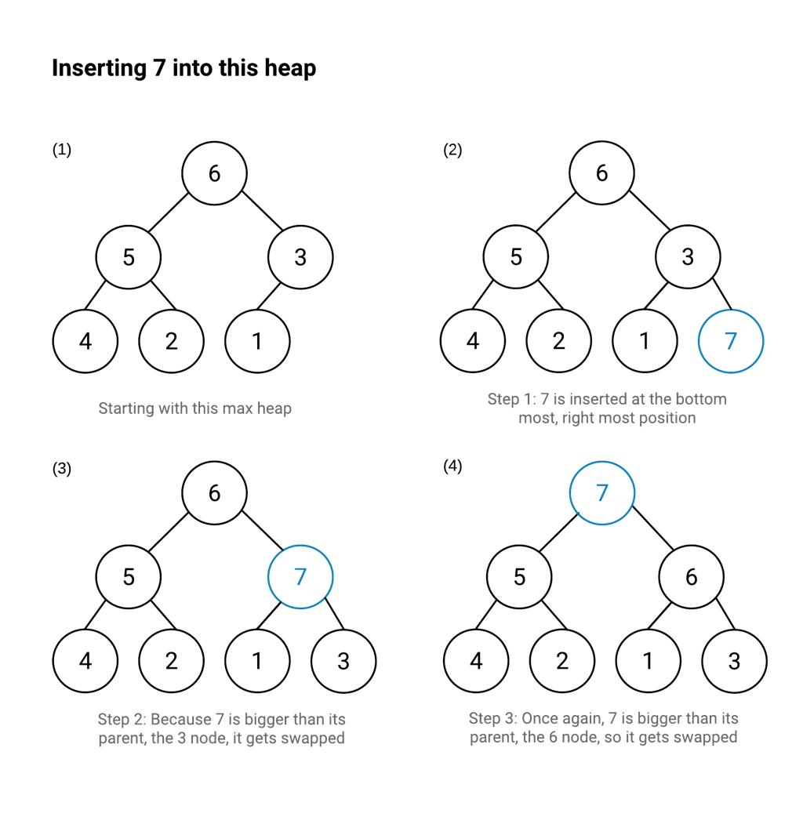
Insertion — sift up
Add the new value at the end of the array. Compare it with its parent and swap when the heap property is violated. Stop at the root or when the property is restored.
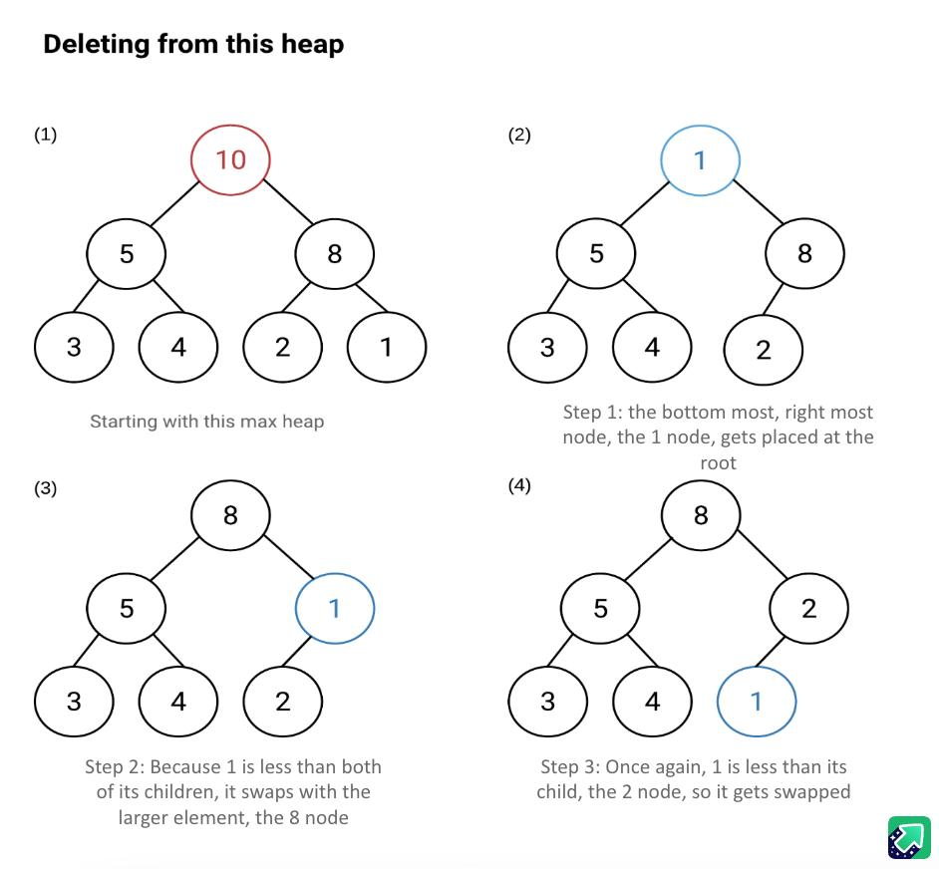
Extract maximum — sift down
Save the root, move the last value to the root, remove the last slot and repeatedly swap with the larger child.
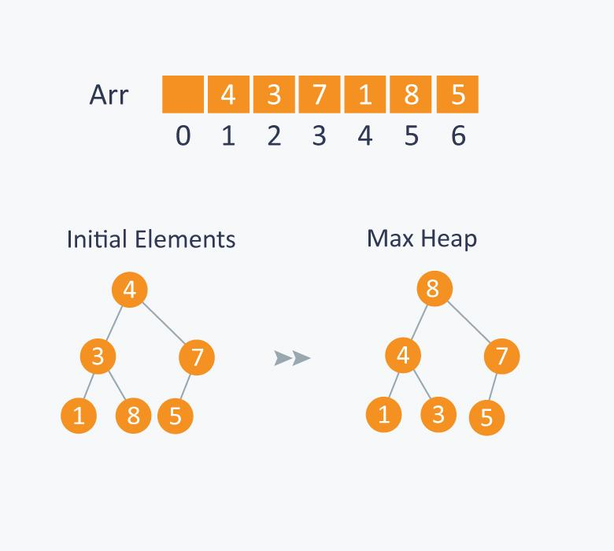
Build heap
Start from the last non-leaf node and sift down each node, moving toward the root. This constructs a heap in \(O(n)\) time.

9. Complete binary heap implementation from scratch
This implementation includes:
- Insert
- Peek maximum
- Extract maximum
- Build from an unsorted vector
- Heap sort
- Display the heap array

#include <iostream>
#include <vector>
#include <stdexcept>
#include <utility>
using namespace std;

class MaxHeap {
private:
vector<int> heap;

void siftUp(int i) {
while (i > 0) {
int parent = (i - 1) / 2;

if (heap[parent] >= heap[i]) {
break;
}

swap(heap[parent], heap[i]);
i = parent;
}
}

void siftDown(int i, int size) {
while (true) {
int largest = i;
int left = 2 * i + 1;
int right = 2 * i + 2;

if (left < size && heap[left] > heap[largest]) {
largest = left;
}

if (right < size && heap[right] > heap[largest]) {
largest = right;
}

if (largest == i) {
break;
}

swap(heap[i], heap[largest]);
i = largest;
}
}

void buildHeap() {
for (int i = static_cast<int>(heap.size()) / 2 - 1;
i >= 0; --i) {
siftDown(i, static_cast<int>(heap.size()));
}
}

public:
MaxHeap() = default;

explicit MaxHeap(const vector<int>& values)
: heap(values) {
buildHeap();
}

bool empty() const {
return heap.empty();
}

int size() const {
return static_cast<int>(heap.size());
}

void insert(int value) {
heap.push_back(value);
siftUp(size() - 1);
}

int top() const {
if (empty()) {
throw out_of_range("Heap is empty");
}
return heap[0];
}

int extractMax() {
if (empty()) {
throw out_of_range("Heap is empty");
}

int result = heap[0];
heap[0] = heap.back();
heap.pop_back();

if (!empty()) {
siftDown(0, size());
}

return result;
}

void heapSortAscending() {
int n = size();

for (int end = n - 1; end > 0; --end) {
swap(heap[0], heap[end]);
siftDown(0, end);
}
}

void display() const {
for (int value : heap) {
cout << value << ' ';
}
cout << '\n';
}
};

int main() {
vector<int> values = {40, 10, 70, 20, 90, 30};

MaxHeap heap(values);

cout << "Built heap: ";
heap.display();

cout << "Maximum: " << heap.top() << '\n';

heap.insert(100);
cout << "After inserting 100: ";
heap.display();

cout << "Extracted maximum: "
<< heap.extractMax() << '\n';

cout << "After extraction: ";
heap.display();

MaxHeap sortable(values);
sortable.heapSortAscending();

cout << "Sorted ascending: ";
sortable.display();

return 0;
}

Heap sort explanation
Heap sort uses the max-heap to repeatedly move the largest remaining element to the end of the array.
- Build a max-heap.
- Swap the root with the last element in the active heap.
- Shrink the active heap by one.
- Restore the heap property with sift down.
- Repeat until sorted.
Complexity:
- Build heap: \(O(n)\).
- Sorting: \(O(n\log n)\).
- In-place auxiliary space: \(O(1)\) beyond the array storage for this iterative implementation.
- Stability: not stable.
Note that heapSortAscending() rearranges the internal vector so that it is sorted, after which it no longer satisfies the max-heap property. Do not call extractMax() expecting heap behavior after sorting.

Part 3 — Priority queue
10. Priority queue fundamentals
A priority queue removes elements based on priority, not arrival order.
Structure | Removal rule | Common use
Normal queue | First in, first out | Task arrival order
Stack | Last in, first out | Undo operations
Max-priority queue | Largest value first | Maximum tracking
Min-priority queue | Smallest value first | Shortest-path algorithms
C++ implements priority_queue using a heap by default.
Program A — max-priority queue

#include <iostream>
#include <queue>
using namespace std;

int main() {
priority_queue<int> pq;

for (int x : {30, 50, 10, 80, 20}) {
pq.push(x);
}

cout << "Top: " << pq.top() << '\n';

pq.pop();

cout << "After pop: " << pq.top() << '\n';

cout << "All elements: ";
while (!pq.empty()) {
cout << pq.top() << ' ';
pq.pop();
}

cout << '\n';
return 0;
}
Program B — min-priority queue

#include <iostream>
#include <queue>
#include <vector>
#include <functional>
using namespace std;

int main() {
priority_queue<int, vector<int>, greater<int>> pq;

for (int x : {30, 50, 10, 80, 20}) {
pq.push(x);
}

while (!pq.empty()) {
cout << pq.top() << ' ';
pq.pop();
}

cout << '\n';
return 0;
}
Output: 10 20 30 50 80

11. Custom priority queue — schedule urgent tasks first
Real applications often prioritize records rather than plain integers.
Suppose each task has a priority number, where a smaller number means higher priority.

#include <iostream>
#include <queue>
#include <string>
#include <vector>
using namespace std;

struct Task {
int priority;
string name;
};

struct CompareTask {
bool operator()(const Task& a, const Task& b) const {
if (a.priority != b.priority) {
return a.priority > b.priority;
}

return a.name > b.name;
}
};

int main() {
priority_queue<Task, vector<Task>, CompareTask> tasks;

tasks.push({3, "Write report"});
tasks.push({1, "Fix critical bug"});
tasks.push({2, "Review code"});
tasks.push({1, "Restore service"});

while (!tasks.empty()) {
Task task = tasks.top();
tasks.pop();

cout << task.priority << " - "
<< task.name << '\n';
}

return 0;
}
Output:
1 - Restore service
1 - Fix critical bug
2 - Review code
3 - Write report
The comparator establishes the priority order. When priorities match, the task name breaks the tie lexicographically.
For a C++ priority queue, the comparator returns true when its first argument should come after its second argument in the queue's ordering.

12. Top K largest elements
This is one of the most useful heap interview patterns.
Problem: Find the \(k\) largest values without sorting the whole array.

#include <iostream>
#include <queue>
#include <vector>
using namespace std;

vector<int> kLargest(const vector<int>& nums, int k) {
priority_queue<int, vector<int>, greater<int>> minHeap;

if (k <= 0) {
return {};
}

for (int value : nums) {
minHeap.push(value);

if (static_cast<int>(minHeap.size()) > k) {
minHeap.pop();
}
}

vector<int> result;

while (!minHeap.empty()) {
result.push_back(minHeap.top());
minHeap.pop();
}

return result; // Ascending order
}

int main() {
vector<int> nums = {12, 5, 30, 7, 18, 25, 2};

int k = 3;
vector<int> result = kLargest(nums, k);

cout << k << " largest values: ";
for (int value : result) {
cout << value << ' ';
}

cout << '\n';
return 0;
}
Output:
3 largest values: 18 25 30
The min-heap retains only the largest three values encountered so far. Its smallest value is the easiest one to remove when a better candidate arrives.
- Time: \(O(n\log k)\).
- Extra space: \(O(k)\).
- If \(k\) exceeds the number of elements, the implementation returns all elements.
If the problem requires the largest distinct values, duplicates must be handled separately.

13. Kth largest element
The same approach works for finding the Kth largest value.
For example, in [3, 2, 1, 5, 6, 4], the second-largest value is 5.

#include <iostream>
#include <queue>
#include <vector>
#include <stdexcept>
using namespace std;

int kthLargest(const vector<int>& nums, int k) {
if (k < 1 || k > static_cast<int>(nums.size())) {
throw invalid_argument("Invalid k");
}

priority_queue<int, vector<int>, greater<int>> minHeap;

for (int value : nums) {
minHeap.push(value);

if (static_cast<int>(minHeap.size()) > k) {
minHeap.pop();
}
}

return minHeap.top();
}

int main() {
vector<int> nums = {3, 2, 1, 5, 6, 4};

try {
cout << "2nd largest: "
<< kthLargest(nums, 2) << '\n';
} catch (const exception& e) {
cerr << e.what() << '\n';
return 1;
}

return 0;
}
Time: \(O(n\log k)\); extra space: \(O(k)\). This counts duplicate values separately, matching the usual definition of the Kth largest element in a multiset.

Part 4 — Advanced hashing and heap patterns
14. Top K frequent elements
Problem: Given a list of integers, return the \(k\) values with the highest frequency.
The solution combines a hash map for counting with a heap for ranking.

#include <iostream>
#include <unordered_map>
#include <queue>
#include <vector>
#include <functional>
using namespace std;

vector<int> topKFrequent(const vector<int>& nums, int k) {
unordered_map<int, int> frequency;

for (int value : nums) {
++frequency[value];
}

// Pair = {frequency, value}.
// A min-heap keeps the lowest frequency at the top.
using Entry = pair<int, int>;

priority_queue<Entry, vector<Entry>, greater<Entry>> heap;

for (const auto& entry : frequency) {
heap.push({entry.second, entry.first});

if (static_cast<int>(heap.size()) > k) {
heap.pop();
}
}

vector<int> result;

while (!heap.empty()) {
result.push_back(heap.top().second);
heap.pop();
}

return result;
}

int main() {
vector<int> nums = {1, 1, 1, 2, 2, 3, 4, 4, 4, 4};

int k = 2;
vector<int> result = topKFrequent(nums, k);

cout << "Top " << k << " frequent values: ";

for (int value : result) {
cout << value << ' ';
}

cout << '\n';
return 0;
}
The two most frequent values are 4 and 1.
- Counting: expected \(O(n)\).
- Heap operations: \(O(u\log k)\), where \(u\) is the number of distinct values.
- Extra space: \(O(u+k)\).
If frequencies tie, the comparator above uses the value as a tie-breaker. When multiple answers are valid, their order may depend on the problem's requirements.
15. Merge K sorted arrays
Problem: Combine several already-sorted arrays into one sorted array.
A min-heap tracks the smallest currently available element from each array. After removing an element, insert the next element from that same array.

#include <iostream>
#include <queue>
#include <vector>
using namespace std;

struct Node {
int value;
int arrayIndex;
int elementIndex;
};

struct CompareNode {
bool operator()(const Node& a, const Node& b) const {
if (a.value != b.value) {
return a.value > b.value;
}

if (a.arrayIndex != b.arrayIndex) {
return a.arrayIndex > b.arrayIndex;
}

return a.elementIndex > b.elementIndex;
}
};

vector<int> mergeKSortedArrays(
const vector<vector<int>>& arrays
) {
priority_queue<Node, vector<Node>, CompareNode> minHeap;

size_t total = 0;

for (int i = 0; i < static_cast<int>(arrays.size()); ++i) {
total += arrays[i].size();

if (!arrays[i].empty()) {
minHeap.push({arrays[i][0], i, 0});
}
}

vector<int> result;
result.reserve(total);

while (!minHeap.empty()) {
Node current = minHeap.top();
minHeap.pop();

result.push_back(current.value);

int nextIndex = current.elementIndex + 1;
int arrayIndex = current.arrayIndex;

if (nextIndex < static_cast<int>(arrays[arrayIndex].size())) {
minHeap.push({
arrays[arrayIndex][nextIndex],
arrayIndex,
nextIndex
});
}
}

return result;
}

int main() {
vector<vector<int>> arrays = {
{1, 4, 7},
{2, 5, 8},
{3, 6, 9}
};

vector<int> result = mergeKSortedArrays(arrays);

for (int value : result) {
cout << value << ' ';
}

cout << '\n';
return 0;
}
Output: 1 2 3 4 5 6 7 8 9
Let \(N\) be the total number of elements and \(k\) the number of arrays.
- Time: \(O(N\log k)\).
- Heap space: \(O(k)\).
- Result storage: \(O(N)\).
Empty arrays are handled correctly.

16. Running median using two heaps
This pattern is useful when numbers arrive one at a time and we need to maintain the median after every insertion.
Maintain:
- A max-heap for the lower half of the values.
- A min-heap for the upper half.
- Heap sizes that differ by at most one.

#include <iostream>
#include <queue>
#include <vector>
#include <stdexcept>
using namespace std;

class MedianFinder {
private:
priority_queue<int> lower;
priority_queue<int, vector<int>, greater<int>> upper;

public:
void addNum(int value) {
if (lower.empty() || value <= lower.top()) {
lower.push(value);
} else {
upper.push(value);
}

if (lower.size() > upper.size() + 1) {
upper.push(lower.top());
lower.pop();
} else if (upper.size() > lower.size() + 1) {
lower.push(upper.top());
upper.pop();
}

// Ensure every value in lower <= every value in upper.
if (!lower.empty() && !upper.empty()
&& lower.top() > upper.top()) {
int a = lower.top();
int b = upper.top();

lower.pop();
upper.pop();

lower.push(b);
upper.push(a);
}
}

double median() const {
if (lower.empty() && upper.empty()) {
throw out_of_range("No numbers available");
}

if (lower.size() == upper.size()) {
return (static_cast<double>(lower.top())
+ static_cast<double>(upper.top())) / 2.0;
}

return lower.size() > upper.size()
? lower.top() : upper.top();
}
};

int main() {
MedianFinder mf;

for (int value : {5, 2, 10, 4, 8}) {
mf.addNum(value);
cout << "After " << value
<< ", median = " << mf.median() << '\n';
}

return 0;
}
For the values 5, 2, 10, 4, 8, the medians are 5, 3.5, 5, 4.5, 5.
- Insert: \(O(\log n)\).
- Read median: \(O(1)\).
- Space: \(O(n)\).

17. Priority queue for Dijkstra's shortest path
Dijkstra's algorithm uses a min-priority queue to repeatedly process the vertex with the smallest known distance. It works with non-negative edge weights.

#include <iostream>
#include <vector>
#include <queue>
#include <limits>
#include <functional>
using namespace std;

using Edge = pair<int, int>; // {neighbor, weight}
const long long INF = numeric_limits<long long>::max() / 4;

vector<long long> dijkstra(
const vector<vector<Edge>>& graph,
int source
) {
int n = static_cast<int>(graph.size());

if (source < 0 || source >= n) {
throw invalid_argument("Invalid source vertex");
}

vector<long long> dist(n, INF);
priority_queue<
pair<long long, int>,
vector<pair<long long, int>>,
greater<pair<long long, int>>
> pq;

dist[source] = 0;
pq.push({0, source});

while (!pq.empty()) {
auto [currentDistance, u] = pq.top();
pq.pop();

if (currentDistance != dist[u]) {
continue; // Ignore stale queue entries.
}

for (const auto& edge : graph[u]) {
int v = edge.first;
int weight = edge.second;

if (weight < 0) {
throw invalid_argument(
"Dijkstra requires non-negative weights"
);
}

long long candidate = currentDistance + weight;

if (candidate < dist[v]) {
dist[v] = candidate;
pq.push({candidate, v});
}
}
}

return dist;
}

int main() {
int n = 5;
vector<vector<Edge>> graph(n);

auto addEdge = [&](int u, int v, int w) {
graph[u].push_back({v, w});
graph[v].push_back({u, w});
};

addEdge(0, 1, 4);
addEdge(0, 2, 1);
addEdge(2, 1, 2);
addEdge(1, 3, 1);
addEdge(2, 3, 5);
addEdge(3, 4, 3);

vector<long long> dist = dijkstra(graph, 0);

for (int i = 0; i < n; ++i) {
cout << "Distance to " << i << ": ";

if (dist[i] == INF) {
cout << "unreachable";
} else {
cout << dist[i];
}

cout << '\n';
}

return 0;
}
For a graph with \(V\) vertices and \(E\) edges, this implementation has a typical time complexity of \(O((V+E)\log V)\) for a sparse graph using an adjacency list and a binary heap. More precisely, the lazy priority-queue implementation is often bounded by \(O((V+E)\log E)\), depending on how the graph is represented.
Important: Dijkstra's algorithm is not suitable for graphs with negative edge weights. Use an algorithm designed for those cases, such as Bellman–Ford, when necessary.

Part 5 — Advanced concepts and problem-solving strategies
18. Choosing hashing vs. heap
Decision guide
Question 1: Do you need to find a key quickly?
Use unordered_map or unordered_set for expected \(O(1)\) lookup.
Question 2: Do you repeatedly need the smallest or largest element?
Use a min-heap or max-heap for \(O(1)\) access to the root and \(O(\log n)\) insertion/removal.
Question 3: Do you need both frequency information and ranking?
Combine them. Use a hash map to count frequencies, then a heap to retain the top \(k\) entries.
More comparisons
Feature | Hash table | Binary heap
Main purpose | Key-based lookup | Priority-based retrieval
Access to arbitrary key | Expected \(O(1)\) | \(O(n)\) search in general
Access to minimum/maximum | Not inherently supported | \(O(1)\) for the appropriate root
Insert | Expected \(O(1)\) | \(O(\log n)\)
Delete a specific key | Expected \(O(1)\) when found, with suitable implementation | \(O(n)\) to locate it, then restore heap in \(O(\log n)\)
Maintains sorted order | No | No
Typical applications | Caching, indexing, duplicate detection | Scheduling, top K, shortest paths
A heap does not replace a hash table, and a hash table does not replace a heap. Choose the structure based on the operation the problem needs most frequently.

19. Important STL distinctions
Container | Key property
unordered_map | Unique keys, key-value pairs, average \(O(1)\) lookup
unordered_set | Unique values, average \(O(1)\) lookup
map | Sorted unique keys, \(O(\log n)\) lookup
set | Sorted unique values, \(O(\log n)\) lookup
priority_queue<int> | Largest value at the top
priority_queue<int, vector<int>, greater<int>> | Smallest value at the top
Use map or set when sorted traversal or ordered operations matter. Use unordered containers when average-case fast lookup is the priority.
20. Common mistakes in interviews and exams
- Assuming hashing is always \(O(1)\). Its worst-case operation time can be \(O(n)\).
- Assuming a heap is sorted. A heap only maintains the parent-child ordering property.
- Using a max-heap for the wrong top-K strategy. A min-heap of size \(k\) is often convenient for retaining the \(k\) largest values.
- Forgetting top() before pop(). priority_queue::pop() does not return the removed element.
- Using an empty heap. Calling top() or pop() on an empty priority queue is invalid.
- Deleting an open-addressing entry by marking it empty. This can break later searches; use a tombstone.
- Forgetting the heap's indexing convention. The formulas differ depending on whether indexing starts at 0 or 1.
- Using Dijkstra with negative edge weights. The algorithm assumes non-negative weights.
- Ignoring duplicate values. Clarify whether the question asks for the Kth largest element counting duplicates or the Kth largest distinct element.
- Writing an incorrect custom comparator. Test the priority order with at least three entries, including a tie.

21. Complexity revision sheet
Algorithm or operation | Time | Extra space
Hash table search, expected | \(O(1)\) | —
Hash table search, worst case | \(O(n)\) | —
Frequency counting | Expected \(O(n)\) | \(O(u)\)
Duplicate detection | Expected \(O(n)\) | \(O(n)\)
Heap peek | \(O(1)\) | \(O(1)\)
Heap insertion | \(O(\log n)\) | \(O(1)\) auxiliary, excluding storage growth
Heap extract root | \(O(\log n)\) | \(O(1)\) auxiliary
Build binary heap | \(O(n)\) | Depends on whether input storage is copied
Heap sort | \(O(n\log n)\) | \(O(1)\) auxiliary for iterative in-place version
K largest elements | \(O(n\log k)\) | \(O(k)\)
Top K frequent | Expected \(O(n+u\log k)\) | \(O(u+k)\)
Merge K sorted arrays | \(O(N\log k)\) | \(O(k)\) heap, plus \(O(N)\) output
Running median insertion | \(O(\log n)\) | \(O(n)\) total storage
Dijkstra with binary heap | Typically \(O((V+E)\log V)\) for sparse graphs | \(O(V+E)\)
Here, \(n\) is the number of input elements, \(u\) is the number of distinct values, \(k\) is the number of requested top elements or sorted arrays, and \(N\) is the total number of elements across those arrays.

